Ochanomizu University Visit to Malaysia
Two administrative staffs from Ochanomizu University, Japan visited Malaysia from 16th until 20th January, 2017. They are Ms. Noriko Ohno and Mr. Tatsuya Konishi. Their visit was like a two-way purpose, as in the morning they attended an English Course classes while in the afternoon Tsukuba Satellite Office facilitate their visiting cum interviewing session to get information from MJIIT, University of Malaya (UM), University Kuala Lumpur (UniKL) and Malaysia-Japan Higher Education Program (MJHEP). Their topic of discussion were on student recruitment, student development and support system, financial aids, hostel and dormitory, industrial training and cooperation with industries. Apart from that they also visited Masjid UTMKL, Library (PSZ) and Business & Advanced Technology Centre (BATC Lodge).
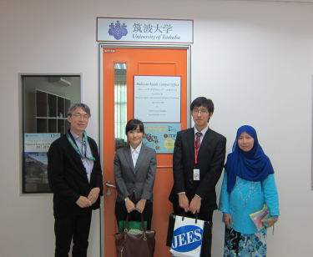 At the Tsukuba Satellite Office, MJIIT, UTM Kuala Lumpur.
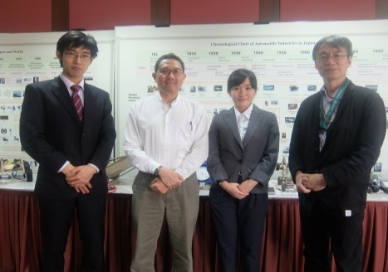With Assoc. Prof. Dr. Abd. Rahman (Director, UTM International Ofice) at the Marzuki Khaled Industrial Museum, MJIIT, UTM Kuala Lumpur.
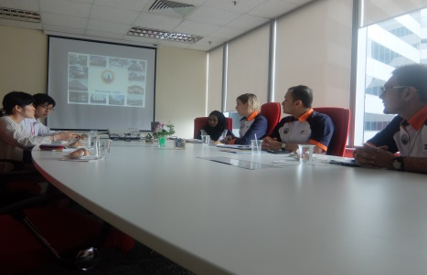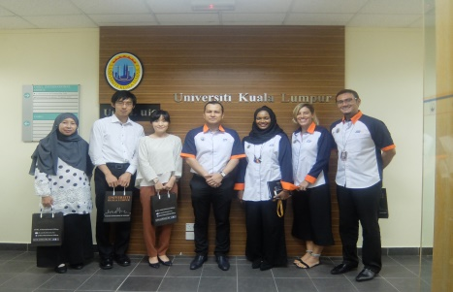 At UniKL - With Dr. Shahro Sharina Shahrin (Deputy Director, UniKL International Ofice, Chiara Marcheschi (Initiative & Development Div), Zambri Pawancik (GM Marketing & Recruitment Div.) and Mohd Azhar (Marketing, Student Recruitment & Admission)
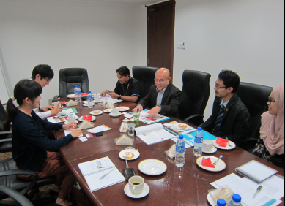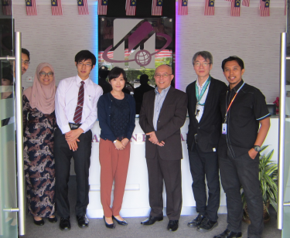 At MJHEP- With Mr. Mat Zailani (Project Director), Mr. Khairil Amri (Manager Coordination Unit), Mr. Mohd Azrul (Head of Program), Mr. Muhammad Al-Hakim (Head of Japanese Language Lecturer), Nor Azizam (Student Affairs)
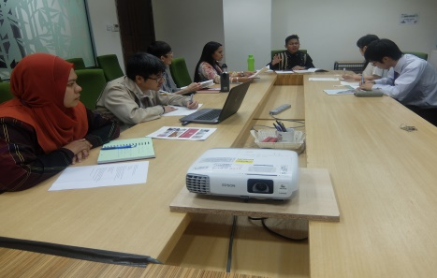 At MJIIT- With Mohd. Sharil (Deputy Registrar), Dr. Pramila (Student Development), Dr. Toh Hoong Thiam (Industrial Training), Dr. Jun Ishimatsu and Mazliza Aini (Financial Div.)
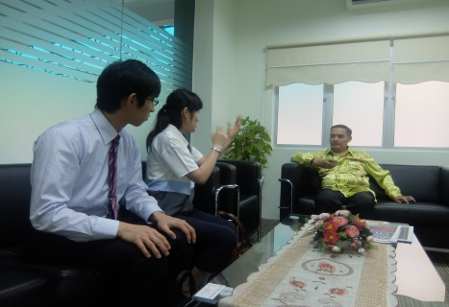 With Student Housing (KSJ) Principal, Assoc. Prof. Dr. Aminudin Abu.

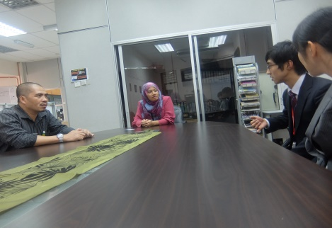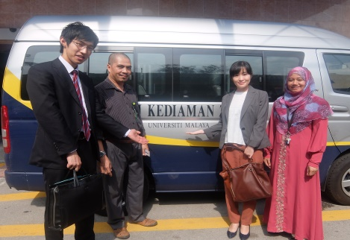 At Za’ba (7th) Residential College, UM – With Domestic Manager, Rogayah Abd Kadir and Zainurin Yatni (College Supervisor)

Report by: Tuan Azma Tuan Ismail (UT KL Ofice)

